# Brand Guidelines

## 

## Using CoderDojo in text:

* CoderDojo should always be used as one word and not 2.
* The D on dojo should be a capital (CamelCase) eg. CoderDojo
* Individuals clubs are Dojos and not CoderDojos.

## Using the Logo:

### Text Beside Logo V’s Text Below Logo

Our preferred logo is with the text to the right hand side of the logo however we know that sometimes a long low logo does not fit, in this case you can use the alternative.

### 

### 

### 

### Text in Black:

CoderDojo text is used in black when on a light background or image.

### 

### Text in White:

CoderDojo text is used in white when on a dark background or image.



### Ways the logo should not be used:

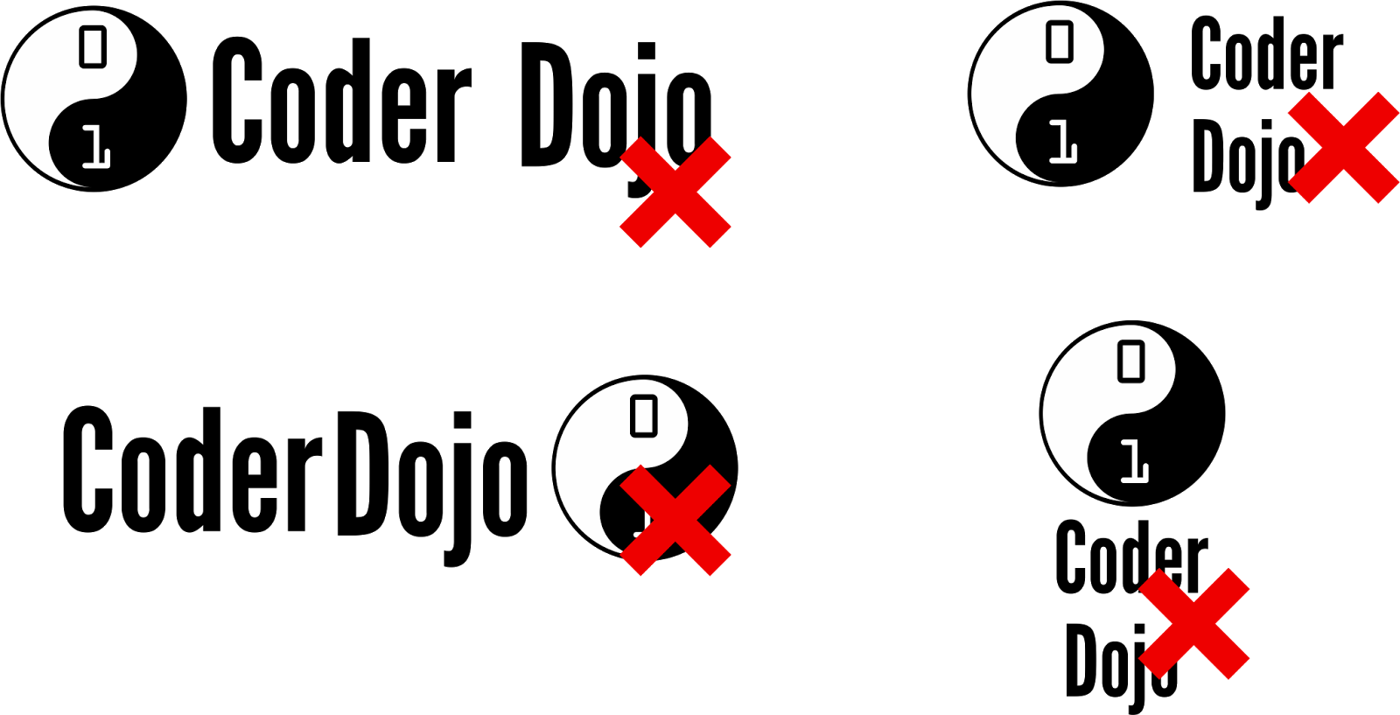

## Using the logo for your Dojo:

While we would love you to use the original CoderDojo logo as part of you Dojos logo it is not a requirement and we have no rules or guidelines regarding the use of the original logo by individual Dojo’s, go wild and submit your logo to be included here.

Here are some examples of cool logo from around the community:

 

 

 